**[Banking System]**

**Task-1:**

**1] Create Database:**

mysql> create database HMBank;

use HMBank;

**2] Create table:**

**1.Customers:**

CREATE TABLE Customers (

customer_id INT PRIMARY KEY,

first_name VARCHAR(50),

last_name VARCHAR(50),

DOB DATE,

email VARCHAR(100),

phone_number VARCHAR(10),

address VARCHAR(100)

);

mysql > desc Customers;

**+--------------+--------------+------+-----+---------+-------+**

**| Field | Type | Null | Key | Default | Extra |**

**+--------------+--------------+------+-----+---------+-------+**

**| customer_id | int | NO | PRI | NULL | |**

**| first_name | varchar(50) | YES | | NULL | |**

**| last_name | varchar(50) | YES | | NULL | |**

**| DOB | date | YES | | NULL | |**

**| email | varchar(100) | YES | | NULL | |**

**| phone_number | varchar(15) | YES | | NULL | |**

**| address | varchar(100) | YES | | NULL | |**

**+--------------+--------------+------+-----+---------+------**

**2.Accounts:**

Create Table Accounts(

account_id INT Primary key,

customer_id INT,

account_type ENUM('savings', 'current', 'zero_balance') NOT NULL,

balance decimal(10,2) DEFAULT 0

FOREIGN KEY (customer_id) REFERENCES Customers(customer_id)

);

**+--------------+------------------------------------------+------+-----+---------+-------+**

**| Field | Type | Null | Key | Default | Extra |**

**+--------------+------------------------------------------+------+-----+---------+-------+**

**| account_id | int | NO | PRI | NULL | |**

**| customer_id | int | YES | | NULL | |**

**| account_type | enum('savings','current','zero_balance') | NO | | NULL | |**

**| balance | decimal(10,0) | YES | | NULL | |**

**+--------------+------------------------------------------+------+-----+---------+-------+**

**3. Transactions:**

Create TABLE Transactions(

transaction_id INT Primary Key,

account_id INT,

transaction_type ENUM('deposit', 'withdrawal', 'transfer') NOT NULL,

amount decimal(15,2) DEFAULT 0,

transaction_date DATE

FOREIGN KEY (account_id) REFERENCES Accounts(account_id)

);

**+------------------+-----------------------------------------+------+-----+---------+-------+**

**| Field | Type | Null | Key | Default | Extra |**

**+------------------+-----------------------------------------+------+-----+---------+-------+**

**| transaction_id | int | NO | PRI | NULL | |**

**| account_id | int | YES | | NULL | |**

**| transaction_type | enum('deposit','withdrawal','transfer') | NO | | NULL | |**

**| amount | decimal(15,2) | YES | | NULL | |**

**| transaction_date | date | YES | | NULL | |**

**4] ER Diagram:**

The Entity Relationship Diagram (ERD) visually represents how Customers, Accounts, and Transactions tables relate to each other.

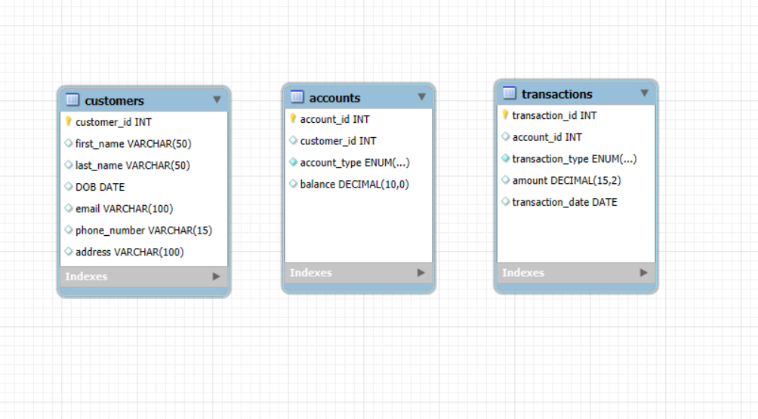

**5] Primary Key and Foreign Key constraints**

| **Table** | **Column** | **Constraint Type** |
| --- | --- | --- |
|  |  |  |
| Customers | customer_id | Primary Key |
| Accounts | account_id | Primary Key |
| Accounts | customer_id | Foreign Key |
| Transactions | transaction_id | Primary Key |
| Transactions | account_id | Foreign Key |  |

**Commands:**

**ALTER, DROP , TRUNCATE ,RENAME**

**>**ALTER TABLE Customers Salary(dno integer);

>ALTER TABLE Customers MODIFY last_name varchar(30);

> ALTER TABLE Transactions

DROP COLUMN transaction_date**;**

**>**TRUNCATE Table Accounts;

>alter table Transactions RENAME COLUMN transaction__type TO tratype_name;

**>**DROP Table Accounts;

>ALTER TABLE Customers RENAME TO Clients;